

Rapid Snapshot
Technical Architecture

Prepared by: Rapid Solutions and Consulting LLC
Last Updated: January 13, 2016

Table of Contents
1. Introduction 3
2. Oracle Configurations storage 4
3. RapidSnapshot Schemas creation 5
4. RapidSnapshot Connection 6
5. RapidSnapshot Snapshot Creation 7
6. Benchmark 8

1. Introduction

RapidSnapshot leverages the EBS (E-Business Suite) Database (speed, SGA, disk space) in order to provide the end-users with a complete copy of their EBS Configurations to be used for further analysis, documentation, comparison or auditing.
This document will explain what happens behind the scene when using RapidSnapshot to connect to your EBS instance.

2. Oracle Configurations storage

All the Configurations data of your EBS instance are stored in hundreds of small areas owned by Database users (called Schemas) and accessible via Oracle Database objects (tables, synonyms, views) by the APPS Schema.
The APPS Schema is central in accessing those Configurations data by the EBS Application tier thru the Oracle Forms.

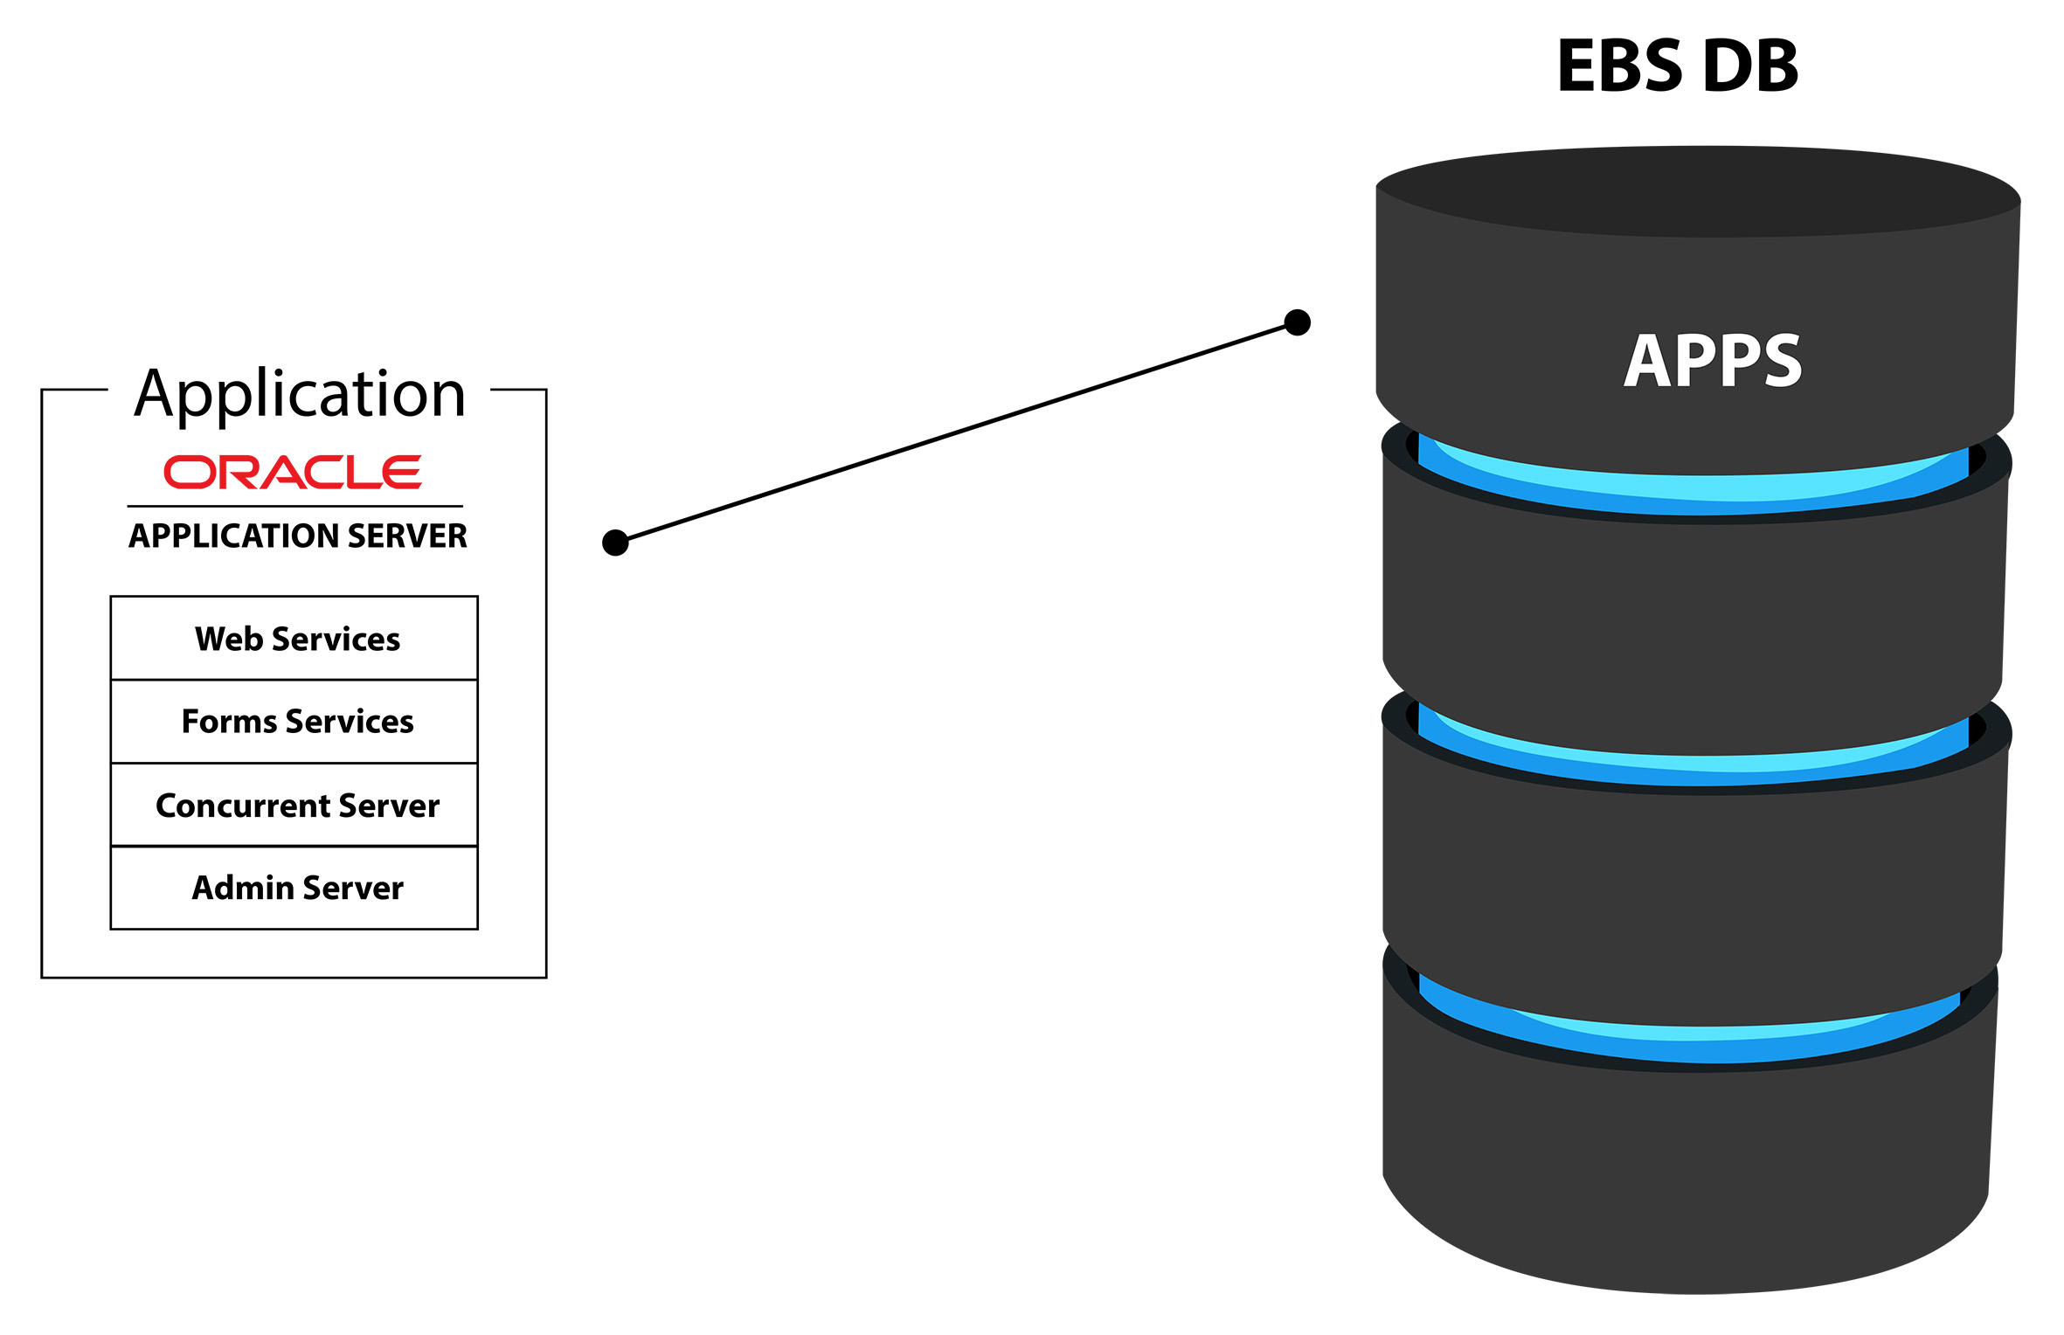

3. RapidSnapshot Schemas creation

Each Consultant will have his/ her own area on the EBS Database to store Snapshots of EBS Configurations Data. Those areas are custom Schemas on the EBS Database created by RapidSnapshot.
Example: When a Consultant called “Mr Smith” wishes to access his Snapshots then he will need to connect to the XX_RS_SMITH Schema.

Note that only the Oracle SYS user has privileges to create such Schemas so only a DBA (Database Administrator) can in practice create the RapidSnapshot Schemas (via some special screens provided in RapidSnapshot).

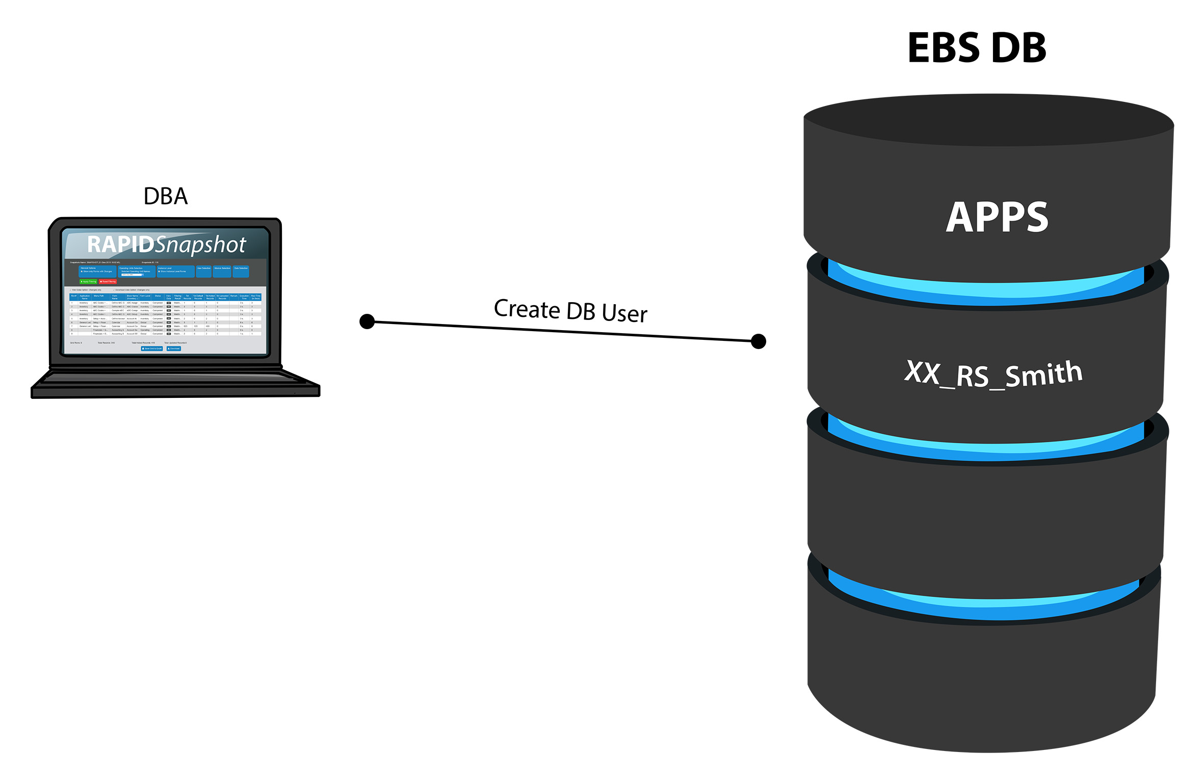

4. RapidSnapshot Connection

EBS Consultants will then use RapidSnapshot to securely connect to their own areas (Schemas). Each of those RapidSnapshot applications are run by different Consultants on different machines.Those users are the only ones to know the credentials to connect to their Schemas.

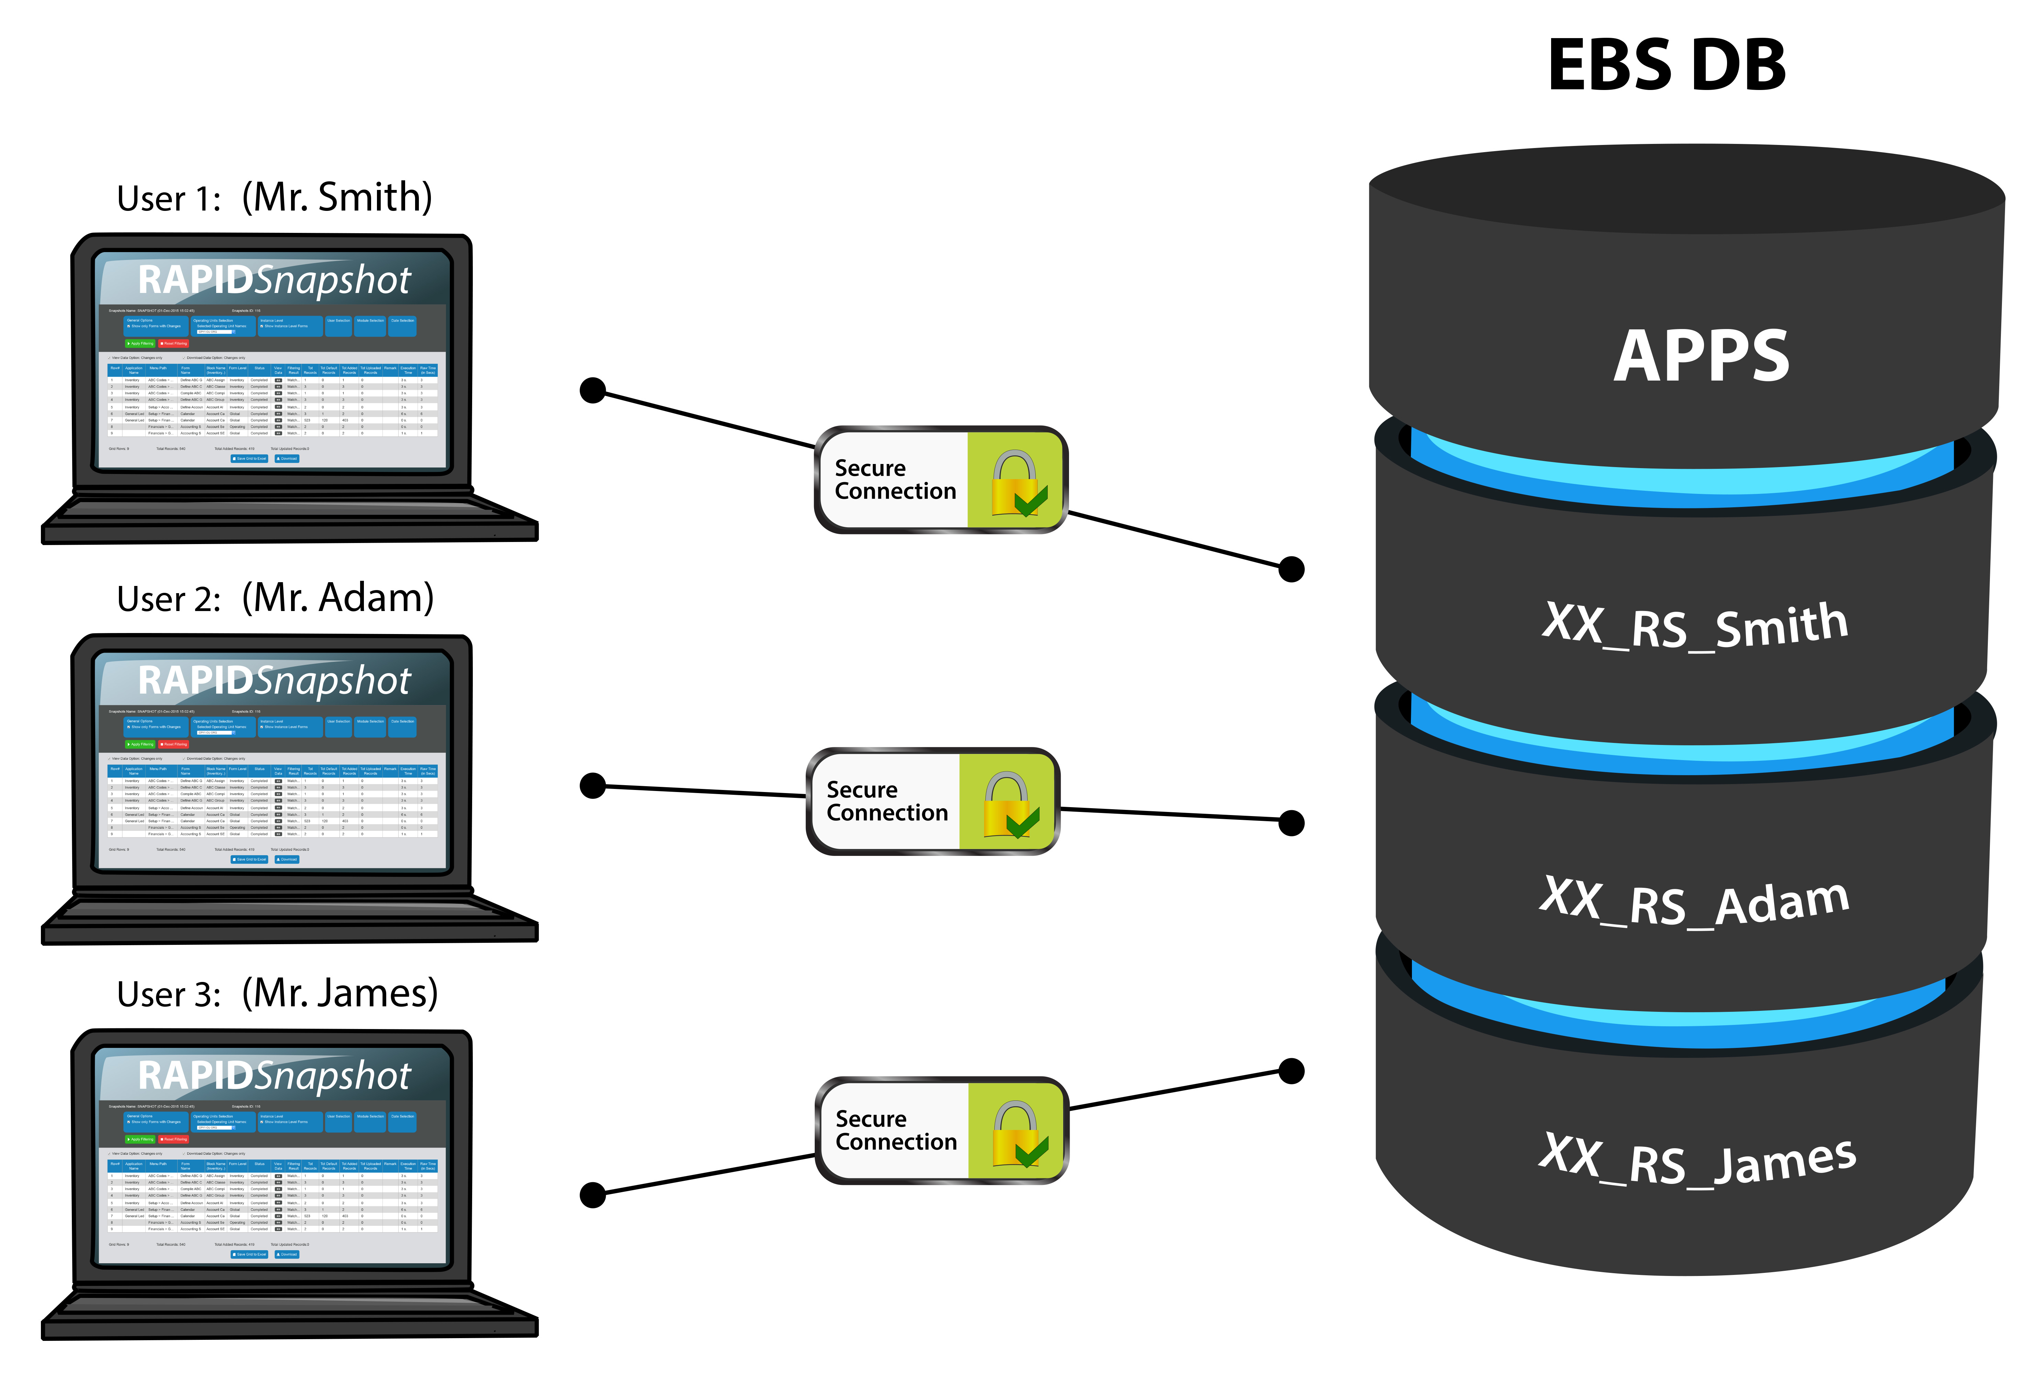

5. RapidSnapshot Snapshot Creation

Once connected to their areas, the EBS Consultants will want to create snapshots of their EBS Configurations.
RapidSnapshot will start copying all EBS Configurations data from the APPS Schema to the custom Schema (Example: XX_RS_SMITH), the end-result is called a “Snapshot”. Multiple Snapshots can be created over time.
All Snapshots reside on the EBS Database but they can now be downloaded in Excel format (BR100) if needed.

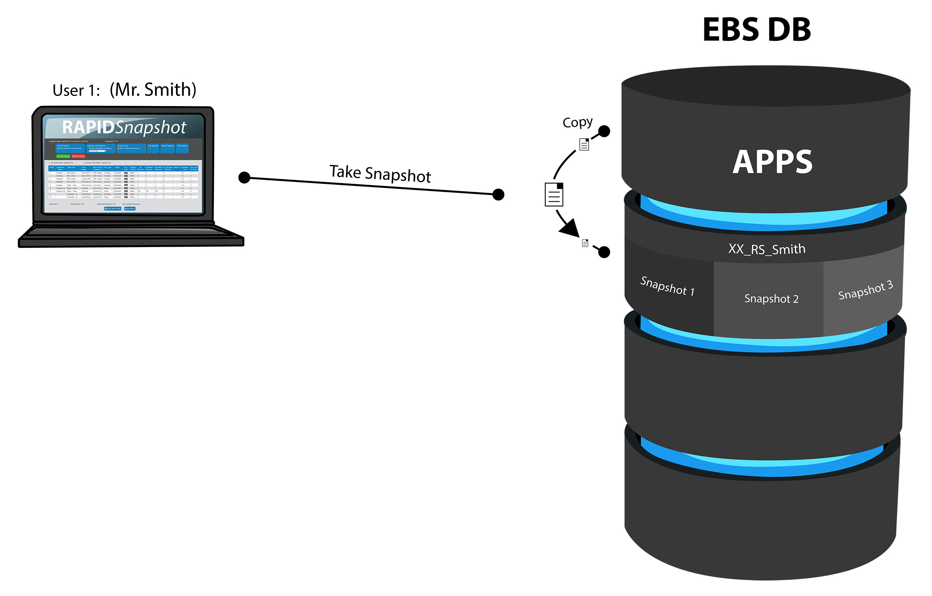

6. Benchmark

The Time and Space that it takes to create a snapshot is greatly dependent on the performance of the EBS Database. See below for some measures:

Speed:
- A snapshot of 2 million Configurations takes 1 hour and 30 minutes with a DB configured with 1 CPU, 1 GB SGA, 1xHDD.

- A snapshot of 2 million Configurations takes 5 minutes with a DB configured with 6 CPUs, 8 GB SGA, SSD hard disk.

Space:
- 1 million Configurations take up about 1 GB of disk space.

